

***Operating systems Lab Work***

***Practical 8***

***Name :Shrey Vyas***

***Batch:F-1***

***Roll Number:22BCE335***

8A.

Code:

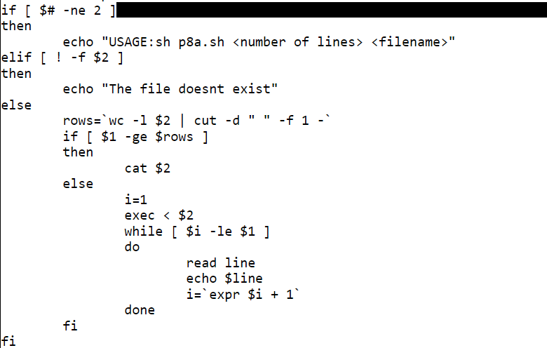

Output:

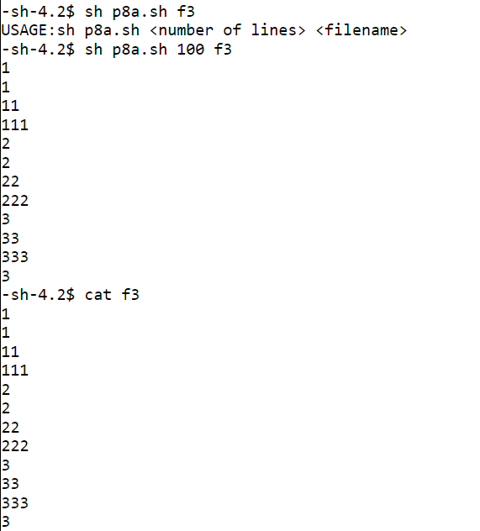

8B.

Code:

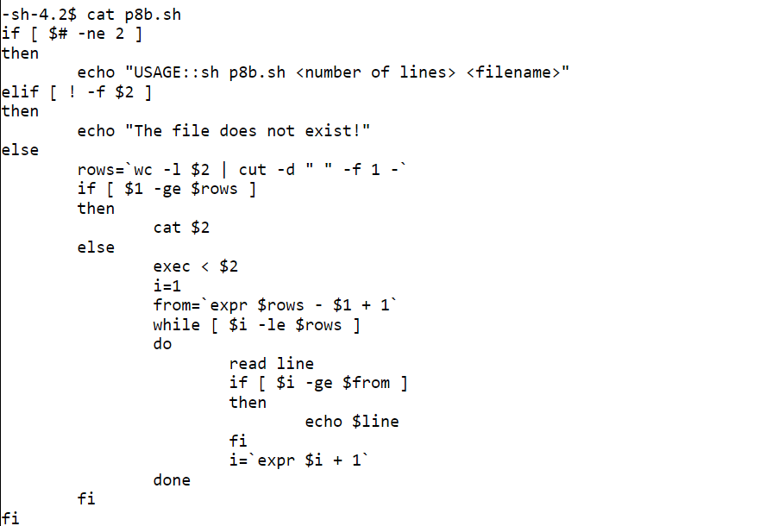

Output:

